https://www.youtube.com/watch?v=fvH865tKOLE

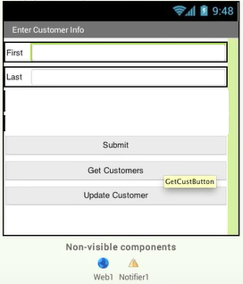

Tutorial de PHP

https://www.youtube.com/watch?v=yPu6qV5byu4

Select a web hosting for the database

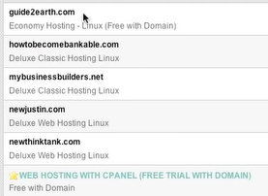

If you select newjustin.com

**Add customer**

**submitCust.php**

<?php

DEFINE ('DBUSER', 'aiusers2');

DEFINE ('DBPW', 'pass');

DEFINE ('DBHOST', 'aiusers2.db57343.hostedresourcepass');

DEFINE ('DBNAME', 'aiusers2');

$dbc = mysqli_connect(DBHOST,DBUSER, DBPW);

if(!$dbc) {

die("Connection failed" . mysqli_error($dbc));

exit();

}

$dbc = mysqli_select_db($dbc, DBNAME);

if(!$dbc) {

die("Selection failed" . mysqli_error($dbc));

exit();

}

$FName = mysqli_real_escape_string($dbc, $_GET['FName']);

$LName = mysqli_real_escape_string($dbc, $_GET['LName']);

$query = "INSERT INTO customer (Fname, Lname)

values ('$FName','$LName')";

$result = mysqliquery($dbc, $query)

or trigger_error("Error" . mysqli_error($dbc));

mysqli_close($dbc);

?>

**Retrieve**

**custcsv.php**

<?php

DEFINE ('DBUSER', 'aiusers2');

DEFINE ('DBPW', 'pass');

DEFINE ('DBHOST', 'aiusers2.db57343.hostedresourcepass');

DEFINE ('DBNAME', 'aiusers2');

$dbc = mysqli_connect(DBHOST,DBUSER, DBPW);

if(!$dbc) {

die("Connection failed" . mysqli_error($dbc));

exit();

}

$dbs = mysqli_select_db($dbc, DBNAME);

if(!$dbc) {

die("Selection failed" . mysqli_error($dbc));

exit();

}

$result = mysqli_query($dbc, "SHOW COLUMNS FROM CUSTOMER");

$numberRows = mysqli_num_rows($result);

if ($numberOfRows >0) {

$values mysqli_query($dbc, "SELECT * FROM CUSTOMER WHERE FNAME ='Fred'");

while($rowr = mysqli_fetch_row($values)) {

for($j=0; $j<$numberOfRows; $j++) {

$csv_output .= $rowr[$j] . ",";

}

$csv_output .= "\n";

}

}

mysqli_close($dbc);

// send data separated by , or newline

print $csv_output;

exit;

?>

**Update**

**updatecust.php**

<?php

DEFINE ('DBUSER', 'aiusers2');

DEFINE ('DBPW', 'pass');

DEFINE ('DBHOST', 'aiusers2.db57343.hostedresourcepass');

DEFINE ('DBNAME', 'aiusers2');

$dbc = mysqli_connect(DBHOST,DBUSER, DBPW);

if(!$dbc) {

die("Connection failed" . mysqli_error($dbc));

exit();

}

$dbc = mysqli_select_db($dbc, DBNAME);

if(!$dbc) {

die("Selection failed" . mysqli_error($dbc));

exit();

}

$FName = mysqli_real_escape_string($dbc, $_GET['FName']);

$LName = mysqli_real_escape_string($dbc, $_GET['LName']);

$query = "UPDATE customer

SET FName = '$FName' ,

LName = '$LName

WHERE ID = $ID ";

$result = mysqliquery($dbc, $query)

or trigger_error("Error" . mysqli_error($dbc));

mysqli_close($dbc);

?>

**Tres variables globales**

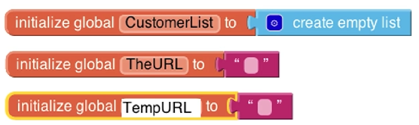

**ADD NEW CUSTOMER**

Llama a **submitcust.php**

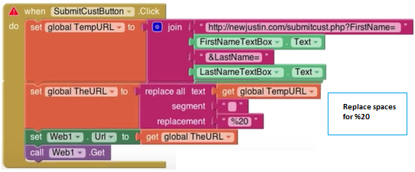

**RETRIEVE DATA AND SHOW LIST**

Trae datoas de custcsv.php separados por “,” y \n

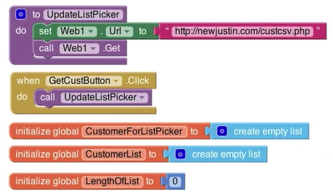

Cuando se da click al buton se actualiza el ListPicker

Este llama a procedimiento que va a base de datos y ejecuta custcsv.php

La información esta separada por “,” y “\n” se cargara en listPickker el FName y LName

En esta parte se formatea la información que ira a listPicker

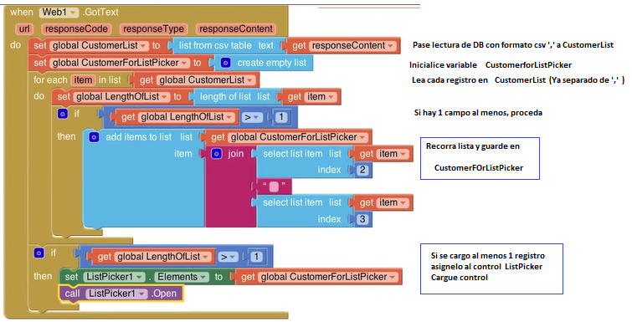

**UPDATE CUSTOMER**

Before update, you have to select from list to change the texts

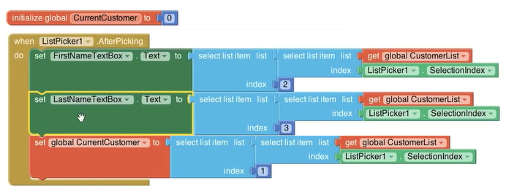



Se verifica que se tiene un **CurrentCustomer**, y se llama a **updatecust.php**

